**Pixel :**In Computer graphics a pixel, dots, or picture element is a physical point in a picture. A pixel is simply the smallest addressable element of a picture represented on a screen.

A majority of pictures that we see on our computer screen are raster images. The selfie that you click with your mobile phone is another example of a raster image. An image is made up using a collection of pixels referred to as a bitmap.

**Bitmap :**In computer graphics, a bitmap is a mapping from some domain (for example, a range of integers) to bits, that is, values which are zero or one. It is also called a bit array or bitmap index.The more general term pixmap refers to a map of pixels, where each one may store more than two colors, thus using more than one bit per pixel. Often bitmap is used for this as well. In some contexts, the term bitmap implies one bit per pixel, while pixmap is used for images with multiple bits per pixel.

Raster images use bit maps to store information. This means a large file needs a large bitmap. The larger the image, the more disk space the image file will take up. As an example, a 640 x 480 image requires information to be stored for 307,200 pixels, while a 3072 x 2048 image (from a 6.3 Megapixel digital camera) needs to store information for a whopping 6,291,456 pixels. We use algorithms which compress images to help reduce these file sizes. Image formats like jpeg and gif are common compressed image formats. Scaling down these images is easy but enlarging a bitmap makes it pixelated or simply blurred. Hence for images which need to scaled to different sizes, we use vector graphics.  
**File extensions:**.BMP, .TIF, .GIF, .JPG

**Vector Graphics**

Making use of sequential commands or mathematical statements or programs which place lines or shapes in a 2-D or 3-D environment is referred to as Vector Graphics. Vector graphics are best for printing since it is composed of a series of mathematical curves. As a result vector graphics print crisply even when they are enlarged. In physics: A vector is something which has a magnitude and direction. In vector graphics, the file is created and saved as a sequence of vector statements. Rather than having a bit in the file for each bit of line drawing we use commands which describe series of points to be connected.  
AS a result a much smaller file is obtained.

**File extensions :**.SVG, .EPS, .PDF, .AI, .DXF

**Conversions:**

**Vector to Raster :** Printers and display devices are raster devices. As a result we need to convert vector images to raster format before they can be used i.e displayed or printed. The required resolution plays an vital role in determining the size of raster file generated. Here it is important to note that the size of vector image to be converted always remains the same. It is convenient to convert a vector file to a range of bitmap/raster file formats but going down opposite path is harder.( because at times we need to edit the image while converting from raster to vector)

**Raster to Vector :** Image tracing in computing can be referred to vectorization and it’s simply the conversion of raster images to vector images. An interesting application of vectorization is to update images and recover work. Vectorization can be used to retrieve information that we have lost. Paint in Microsoft Windows produces a bitmap output file. It is easy to notice jagged lines in Paint. In this kind of a conversion the image size reduces drastically. As a result an exact conversion is not possible in this scenario. Due to various approximations and editing that is done in the process of conversion the converted images are not of good quality.

**Vector Scan or Random Scan Display** in this technique, the electron beam is directed only to the part of the screen where the picture is to be drawn rather than scanning from left to right and top to bottom as in raster scan. It is also called stroke-writing display, or calligraphic display.

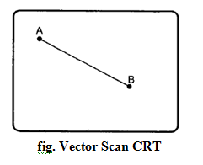

As shown in Fig., vector scan CRT display directly traces out only the desired lines on CRT i.e. If we want a line connecting Point A with Point B on the vector graphics display, we simply drive the beam deflection circuitry, which will cause beam to go directly from Point A to B. If we want to move the beam from point A to Point B without showing a line between points, we can blank the beam as we move it. To move the beam across the CRT, the information about both, magnitude and direction is required. This information is generated with the help of vector graphics generator.

In vector displays beam is deflected from end point to end Point, hence this technique is also called random scan. In this the picture can be draw in terms of line, one at a time. The refresh rate depends on the number of lines to be displayed.

**Raster Scan Display** in this technique the electron beam is swept across the screen one row at a time from top to bottom. As it moves across each row, the beam intensity is turned on and off to create a pattern of illuminated spots. This scanning process is called refreshing. Each complete scanning of a screen is normally called a **frame**.

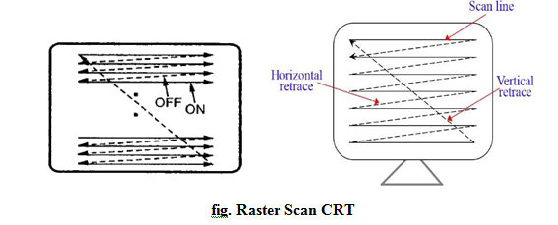

Raster scan is the most common method of displaying images on the CRT screen. In this method, the horizontal and vertical deflection signals are generated to move the beam all over the screen in a pattern shown in the Fig. Here, the beam is swept back and forth from the left to the right across the screen. when the beam is moved from the left to the right, it is ON. The beam is OFF, when it is moved from the right to the left as shown by dotted line in Fig. The refreshing rate, called the frame rate, is normally 60 to 80 frames per second.

Picture definitions is stored in a memory area called the **frame buffer**. **This frame buffer stores the intensity values for all the screen points. Each screen point is called a pixel (picture element).**

On black and white systems, the frame buffer storing the values of the pixels is called a **bitmap**. Each entry in the bitmap is a 1-bit data which determine the **ON** (1) and **OFF** (0) of the intensity of the pixel. On color systems, the frame buffer storing the values of the pixels is called a **pixmap**. Each entry in the pixmap occupies a number of bits to represent the color of the pixel.

